Nominal Clause Subject

✅ What is Nominal Clause Subject
# Source: AI Source: Provided by: [Data Path: Persons Table -> ID Column: 1, Name_En Column: Motasem Essam] -> From: [Chatgpt (GPT-4-turbo)] on [8/4/2025]
A nominal clause subject (also called a noun clause subject) is a dependent clause that functions as a noun and acts as the subject of the sentence.
It answers “what?” or “who?” in the sentence — just like a noun.

🔹 Common Introductory Words:
# Source: AI Source: Provided by: [Data Path: Persons Table -> ID Column: 1, Name_En Column: Motasem Essam] -> From: [Chatgpt (GPT-4-turbo)] on [8/4/2025]
- That
- What
- Whether
- Who / Whom
- How / Why / When / Where

🔹 Key Features:
# Source: AI Source: Provided by: [Data Path: Persons Table -> ID Column: 1, Name_En Column: Motasem Essam] -> From: [Chatgpt (GPT-4-turbo)] on [8/4/2025]
- Contains a subject and verb.
- Cannot stand alone.
- The entire clause serves as the subject.
- Verb agrees in number with the entire clause, not an internal word.

🔹 Examples:
# Source: AI Source: Provided by: [Data Path: Persons Table -> ID Column: 1, Name_En Column: Motasem Essam] -> From: [Chatgpt (GPT-4-turbo)] on [8/4/2025]
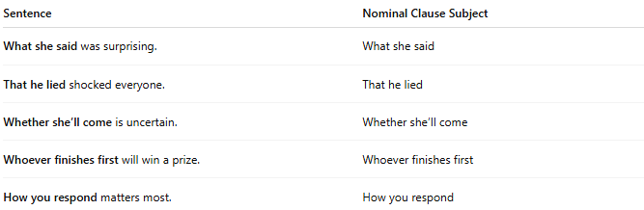
Sentence | Nominal Clause Subject
What she said was surprising. | What she said
That he lied shocked everyone. | That he lied
Whether she’ll come is uncertain. | Whether she’ll come
Whoever finishes first will win a prize. | Whoever finishes first
How you respond matters most. | How you respond

🔍 Tip:
# Source: AI Source: Provided by: [Data Path: Persons Table -> ID Column: 1, Name_En Column: Motasem Essam] -> From: [Chatgpt (GPT-4-turbo)] on [8/4/2025]
If you can replace the clause with "it" or "something", and the sentence still makes sense grammatically, it's probably a nominal clause.
✔ "That he lied" shocked everyone.
✔ "It" shocked everyone.

